BEGINNER WORKSHOP
Hooked Rug Museum of North America (HRMNA)
9849 St. Margaret’s Bay Road, Hwy 3, Queensland, NS B0J 1T0

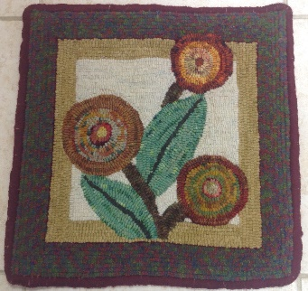 PATTERN - PRIMITIVE FLOWERS.

GENERAL INFORMATION

DATE: May 2, 2019 Saturday 9:30am - 4:00pm
May 3, 2019 Sunday 9:30am - 4:00pm

LOCATION: Hooked Rug Museum of North America (HRMNA)
9849 St. Margaret’s Bay Road, Hwy 3, Queensland, NS B0J 1T0 902-858-3060
Web: http://www.hookedrugmuseumnovascotia.org email: hookedrugmuseum@gmail.com

TEACHERS: Suzanne Conrod and Sherry Chandler are both Certified McGown Teachers who have taught workshops in Nova Scotia and the United States.

WORKSHOP: The Workshop is open to beginners or to anyone who wishes to improve on their rug hooking skills. A video on “how to hook” will be shown followed by instruction on how to hook and finish the primitive rug shown in the photo above.

REGISTRATION: Registration Form is on the HRMNA web site: www.hookedrugmuseumnovascotia.org
under Tab: Hook-Ins/Workshops
Print registration form and mail with your payment to the
REGISTRAR: HOOK RUG MUSEUM of NORTH AMERICA
9849 St. Margaret’s Bay Road
RR #2, Hubbards, NS B0J 1T0

Confirmation of registration upon receipt of registration form and payment.

A deposit of $60.00 is payable with registration and the balance of $60.00 payable by April 15, 2020. Total registration fee of $120.00 can be paid with registration

Total registration fee for 2 days - $120.00
- includes registration fee
- includes KIT (pattern, wool and hook). The Museum can provide a hoop during the class.
- Hoops can be purchased at the Museum for $30.00 (no tax) - Tea,coffee, muffins Sat & Sun. provided Bring your own lunch.

CANCELLATION/
REFUNDS: No later than April 15, 2020. No refunds after April 15, 2020
The $60.00 deposit is non-refundable, balance of $60.00 is refundable prior to April 15, 2020

KITS: Included in registration fee. Pattern, Wool and Hook.

HOOPS/ HOOKS If you have your own frame or hoop please bring them OR
You can purchase a hoop from the Hooked Rug Museum for $30.00 (no tax) OR
You can borrow a hoop from the Museum for the workshop

** Any questions, please call Sherry Chandler @ 902-275-4743 or email hookedrugmuseum@gmail.com

