BEGINNER RUG HOOKING WORKSHOP (2 days)
Hooked Rug Museum of North America (HRMNA)

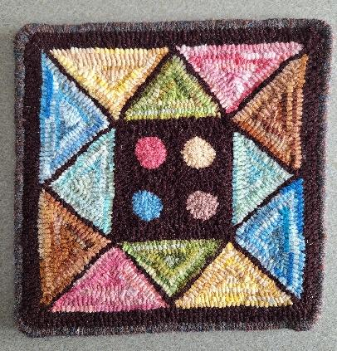

DATE: JULY 18, 2026 Saturday 9:30am - 4:00pm
JULY 19, 2026 Sunday 9:30am - 4:00pm

LOCATION: Hooked Rug Museum of North America (HRMNA)
9849 St. Margaret’s Bay Road, Queensland, NS B0J 1T0 902-858-3060
Web: http://www.hookedrugmuseumnovascotia.org email: hookedrugmuseum@gmail.com

TEACHERS: Suzanne Conrod and Sherry Chandler are both Certified McGown Teachers who have taught many workshops in Nova Scotia and elsewhere.

WORKSHOP: The Workshop is open to beginners or to anyone who wishes to improve on their rug hooking skills. A video on “how to hook” will be shown followed by instruction on how to hook the rug shown in the photo above. Demos will be given on other aspects of rug hooking. See Kit information below.

COST: Total registration fee for 2 days - $120.00 A Deposit of $60.00 is required to register.
- includes KIT (pattern, wool and hook) and registration fee

REGISTRATION: Click here to Download, Print and Fill in the Registration Form. It cannot be completed online.
Scan and email it to: hrmnaevents@gmail.com OR mail it to the Registrar at the address below.

- E-TRANSFER your deposit or payment in full to: hrmnaevents@gmail.com
OR
- CHEQUE – Mail cheque and registration form to the address below.
OR
- MUSEUM – Stop into the Museum, fill out a registration form and make payment at the front counter.

MAIL TO: REGISTRAR: HOOKED RUG MUSEUM of NORTH AMERICA
9849 St. Margaret’s Bay Road, Queensland, NS B0J 1T0

Confirmation of registration upon receipt of both registration form and payment.

Coffee,tea will be provided. Please bring your own lunch, snacks, cutlery and mug.
Please do not bring anything with nuts due to severe allergy concerns.

KITS: Included in registration fee. Pattern, Wool and Hook. Please bring your own scissors.

HOOPS/ HOOKS If you have your own frame or hoop please bring them OR
You can purchase a hoop from the Hooked Rug Museum OR
You can borrow a hoop from the Museum for the workshop

CANCELLATION/
REFUNDS: Deposit of $60.00 refundable prior to JULY 1, 2026. No refunds after JULY 1, 2026

** Any questions, please call Sherry Chandler @ 902-275-4743 or email hookedrugmuseum@gmail.com

