DIAMOND GEOMETRIC WORKSHOP
Hooked Rug Museum of North America

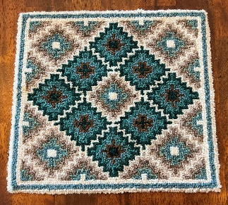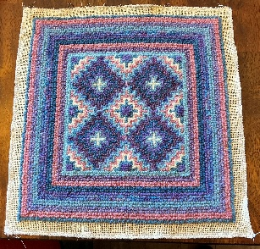

DATE: September 16, 2026 Wednesday 10:30 am - 4:30 pm

LOCATION: Hooked Rug Museum of North America (HRMNA)
9849 St. Margaret’s Bay Road, Hwy 3, Queensland, NS B0J 1T0 902-858-3060
Web: http://www.hookedrugmuseumnovascotia.org email: hookedrugmuseum@gmail.com

TEACHER: Liz Young , past teacher from the RHGNL and long term member of the Rug Hooking Guild of Nova Scotia, now permanently resides in Nova Scotia. In July 2024 she was the proud feature “Artist of the Month” at the Shoreline Gallery, Bridgewater Hospital, Bridgewater, NS. Liz is now introducing NEW Geometric Rug Hooking Workshops. She continues to teach rug hooking workshops in Canada and throughout a variety of European countries i.e. Portugal, Spain, Italy and the UK. Some of her finished pieces are for sale in the Fibre Market at the Hooked Rug Museum of North America.

WORKSHOP: With the NEW Geometric designs, we continue to explore the Aztec stitch and some colour planning. Using yarn, learn how to create this lovely wall hanging, chair pad or table mat. You can choose to hook or punch it (drawn on linen), either by traditional hooking with yarn and regular hook, or by punching it with an Amy Oxford #14 punch hook. Choose from either the Diamond or the Square geometric design. PS: Don’t forget to bring your camera!

Pattern is drawn on linen approx. 20” x 20”, 2 pictures of finished sample (right and wrong side), detailed pattern on graph paper to repeatedly reproduce the pattern on future projects and pattern instructions for the Aztec stitch. Yarn is not included.

SUPPLIES: You will need approx. 1 ounce of yarn in each of 6 colours in values from dark to light, plus Black and White, if using for highlights, low lights and the borders. Traditionally, we use Briggs & Little “Regal” or “Heritage” yarn. Bring your rug hook OR your #14 Amy Oxford Punch Hook, your regular hooking supplies, scissors, a fine sharpie, pencil and notebook.
At the workshop, Liz will have a variety of yarns and kits available for purchase.

COST: Total cost of workshop $115.00 A Deposit of $60.00 is required to register.

REGISTRATION: Click here to download. Print and fill in the registration form. It cannot be completed online.
Scan and email it to: hrmnaevents@gmail.com OR mail it to the Registrar at the address below.

PAYMENT (1) E-TRANSFER your deposit or payment in full to hrmnaevents@gmail.com
OR
(2) CHEQUE – Mail cheque and registration form to the address below.
OR
(3) MUSEUM – Stop into the Museum, fill out a registration form and make payment at the front counter

MAIL TO: REGISTRAR: HOOKED RUG MUSEUM of NORTH AMERICA
9849 St. Margaret’s Bay Road, Queensland, NS B0J 1T0

Confirmation of registration upon receipt of both registration form and payment

- Coffee,tea will be provided. Please bring your own lunch, snacks, cutlery and mug.
- Please do not bring anything with nuts due to severe allergy concerns.

CANCELLATION / REFUNDS: Deposit of $60.00 is refundable prior to August 31st, 2026. No refunds after August 36,1st, 2026.

** Any questions, please call Sherry Chandler @ 902-275-4743 or email hookedrugmuseum@gmail.com

