“FINISHING” YOUR RUG WORKSHOP”
Hooked Rug Museum of North America (HRMNA)
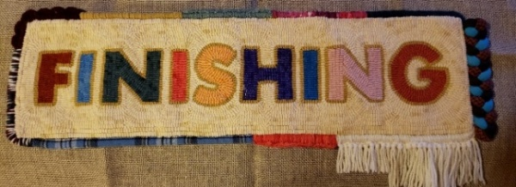
DATE: September 22, 2026 Tuesday 10:00am - 3:00pm

LOCATION: Hooked Rug Museum of North America (HRMNA)
9849 St. Margaret’s Bay Road, Hwy 3, Queensland, NS B0J 1T0 902-858-3060
Web: http://www.hookedrugmuseumnovascotia.org email: hookedrugmuseum@gmail.com

TEACHER: Patsy Gorveatte, Certified Rug Hooking Teacher

WORKSHOP: In this 5-hour workshop you will do some hands-on finishing but to get us to that point, Patsy will review the various tools required to do the job. Patsy will also explain various styles that she has done or researched over the past few years. Her preferred method of choice is whipping over cording but there are so many other ways to make your work of art beautiful as displayed in her finished mat above. Patsy is asking that the students prepare a small 6 x 6-inch trivet/coaster size mat, that you will “whip” finish in the workshop. The design is your choice.
Patsy will bring some sample rugs for you to see how different types of finishes effect the overall look of the rug. She will also bring some reference books for you to look at. She has a very lengthy handout for you to take home and refer back to in future projects.
Supply list you need to bring to class:
- 6 x 6 hooked piece with 2” of linen left all the way around. Finished size to bring to class 10 x 10”.
- 1 yd or meter of cording., ¼ or ½ “ diameter optional. Available at Dollarama (craft section, twisted rope,) or official cording - Fabricville. 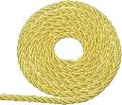 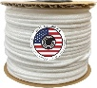
- 1 bent darning needle, bent or straight. Patsy will have some for sale in class $1.00 each. 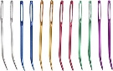
- Scissors, thread any color. Sharp needle to use with the thread
- Twill tape for using on the back to cover the edge of the linen. You can get 1”twill tape at any rug hooking shop. Patsy will have some for sale - $1 a meter. 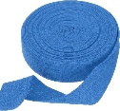
- Wool yarn such as Briggs and Little in a color that matches the edge of your rug/coaster. You can use other yarn but just make sure that it’s not too thick. If you can hook with it, you can probably whip with it. You will need approximately 12” of yarn for every inch of edge. So lets do the math:
- 6+6+6+6=24 inches around the rug plus approximately 1 inch for each corner = total of 28 inches. So, you multiply 28” x 12” = 336” of yarn or 8.625 meters. I’d round that up to 10 meters. You will have to find your own yarn because you will want it to match your rug.
COST: Total registration fee is $85.00 Maximum class size would be 15 in order for Patsy to be able to help everyone fairly.
A Deposit of $40.00 is required to register.

REGISTRATION: Click here to Download, Print and Fill in the Registration Form. It cannot be completed online.
Scan and email it to: hrmnaevents@gmail.com OR mail it to the Registrar at the address below.

- E-TRANSFER your deposit or payment in full to: hrmnaevents@gmail.com
OR
- CHEQUE – Mail cheque and registration form to the address below.
OR
- MUSEUM – Stop into the Museum, fill out a registration form and make payment at the front counter.

MAIL TO: REGISTRAR: HOOKED RUG MUSEUM of NORTH AMERICA
9849 St. Margaret’s Bay Rd, Queensland, NS B0J 1T0

Confirmation of registration upon receipt of both registration form and payment.

Coffee,tea will be provided. Please bring your own lunch, snacks, cutlery and mug.
Please do not bring anything with nuts due to severe allergy concerns.

CANCELLATION/REFUNDS: The $40.00 deposit is refundable prior to September 1, 2026. No refunds after September 1,2026

** Any questions, please call Sherry Chandler @ 902-275-4743 or email hookedrugmuseum@gmail.com

