“FINISHING” YOUR RUG WORKSHOP”
Hooked Rug Museum of North America (HRMNA)
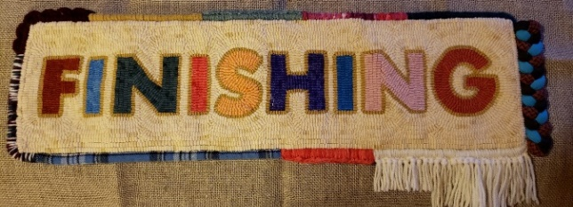

DATE: September 22, 2026 Tuesday 10:00am - 3:00pm

LOCATION: Hooked Rug Museum of North America (HRMNA)
9849 St. Margaret’s Bay Road, Hwy 3, Queensland, NS B0J 1T0 902-858-3060
Web: http://www.hookedrugmuseumnovascotia.org email: hookedrugmuseum@gmail.com

TEACHER: Patsy Gorveatte

WORKSHOP: In this 5-hour workshop you will do some hands-on finishing but to get us to that point, Patsy will review the various tools required to do the job. Patsy will also explain various styles that she has done or researched over the past few years. Her preferred method of choice is whipping over cording but there are so many other ways to make your work of art beautiful as displayed in her finished mat above.
Patsy will have the students either prepare a small 6 x 6-inch trivet size mat that you will finish in the workshop. The design is your choice, but Patsy will explain what size linen is required as well as the materials needed to bring with you for the day. If you prefer to work on finishing a different piece, contact Patsy before the workshop so she can discuss what you need to bring @ 902-476-4946.
Patsy will bring some sample rugs for you to see how different types of finishes effect the overall look of the rug. She will also bring some reference books for you to look at. She has a very lengthy handout for you to take home and refer back to in future projects.
Maximum class size would be 15 in order for her to be able to help everyone fairly.
Supplies: If choosing to do a whipped edge, bring a large blunt needle for whipping. Do not bring a sharp one for whipping. You can pick up the proper whipping needles at stores like Encompassing Designs. Also a pair of scissors and a sewing needle. For the smaller project Patsy will provide the cording and tape for the back and/or felt depending on which method you choose to do.
Call Patsy 902-476-4946 before the class to discuss which method of finishing you wish to do and which supplies you need to bring.
COST: Total registration fee is $85.00
A Deposit of $40.00 is required to register.

REGISTRATION: Click here to Download, Print and Fill in the Registration Form. It cannot be completed online.
Scan and email it to: hrmnaevents@gmail.com OR mail it to the Registrar at the address below.

- E-TRANSFER your deposit or payment in full to: hrmnaevents@gmail.com
OR
- CHEQUE – Mail cheque and registration form to the address below.
OR
- MUSEUM – Stop into the Museum, fill out a registration form and make payment at the front counter.

MAIL TO: REGISTRAR: HOOKED RUG MUSEUM of NORTH AMERICA
9849 St. Margaret’s Bay Rd, Queensland, NS B0J 1T0

Confirmation of registration upon receipt of both registration form and payment.

Coffee,tea will be provided. Please bring your own lunch, snacks, cutlery and mug.
Please do not bring anything with nuts due to severe allergy concerns.

CANCELLATION/
REFUNDS: The $40.00 deposit is refundable prior to September 1, 2026. No refunds after September 1,2026

** Any questions, please call Sherry Chandler @ 902-275-4743 or email hookedrugmuseum@gmail.com

