GEOMETRIC HIT & MISS CHAIRPAD WORKSHOP
Hooked Rug Museum of North America

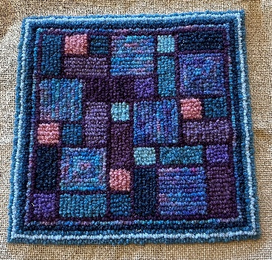

DATE: July 7, 2026 Tuesday 10:30 am - 4:30 pm

LOCATION: Hooked Rug Museum of North America (HRMNA)
9849 St. Margaret’s Bay Road, Hwy 3, Queensland, NS B0J 1T0 902-858-3060

TEACHER: Liz Young , past teacher from the RHGNL and long term member of the Rug Hooking Guild of Nova Scotia, now permanently resides in Nova Scotia. She is a proud feature artist exhibiting her work at the Shoreline Gallery, Bridgewater Hospital, Nova Scotia and continues to teach rug hooking workshops in Canada and throughout a variety of European countries i.e. Portugal, Spain, Italy and the UK. Some of her finished pieces are for sale in the Fibre Market at the Hooked Rug Museum of North America.

WORKSHOP: Using yarn, learn how to create this geometric Hit & Miss design based on 1-inch increments, drawn on linen. Either, by traditional hooking with yarn and regular hook, or, try punching it with a #14 punch tool. You will have a choice in the design to create either a chairpad, table mat or a trivet. After hooking the outline, you will learn not only how to change the colour sequence of each section but to change the style of hooking stitch in each section. Thus, creating not only a rhapsody of colour changes but a symphony of unique hooked or punched stitch styles. PS: Don’t forget to bring your camera !!!

KIT: A kit is provided which includes drawn up detailed linen pattern approx.. 20” x 24”, 2 pictures of finished sample (right side and wrong side), detailed pattern on graph paper to repeatedly reproduce the pattern on future projects and pattern instructions. You will need to bring your regular hooking supplies, your hook or #14 punch hook, frame, scissors, a fine sharpie, pencil and notebook.

YARN: Yarn is included. Bring your own yarns as you will need approx. 8 to 10 different mini skeins plus some extra yarns for outlining and borders. Traditionally, we use Briggs & Little “Regal” or “Heritage” yarn. At the workshop, Liz will have available a nice variety of yarns and some packages of lovely inexpensive Parisienne Tapestry yarn from France (100% wool + moth proof.) Mini skeins (10g) each are also available for sale at the Museum.

COST: Total cost is $115.00 Includes kit and registration. A Deposit of $50.00 is required to register.

REGISTRATION: Click here to download. Print and fill in the registration form. It cannot be completed online.
Scan and email it to: hrmnaevents@gmail.com OR mail it to the Registrar at the address below.

PAYMENT (1) E-TRANSFER your deposit or payment in full to hrmnaevents@gmail.com
OR
(2) CHEQUE – Mail cheque and registration form to the address below.
OR
(3) MUSEUM – Stop into the Museum, fill out a registration form and make payment at the front counter

MAIL TO: REGISTRAR: HOOKED RUG MUSEUM of NORTH AMERICA
9849 St. Margaret’s Bay Road, Queensland, NS B0J 1T0

Confirmation of registration upon receipt of both registration form and payment

- Coffee,tea will be provided. Please bring your own lunch, snacks, cutlery and mug.
- Please do not bring anything with nuts due to severe allergy concerns.

CANCELLATION / REFUNDS: Deposit of $50.00 is refundable prior to June 15, 2026. No refunds after June 15, 2026.

** Any questions, please call Sherry Chandler @ 902-275-4743 or email hookedrugmuseum@gmail.com

