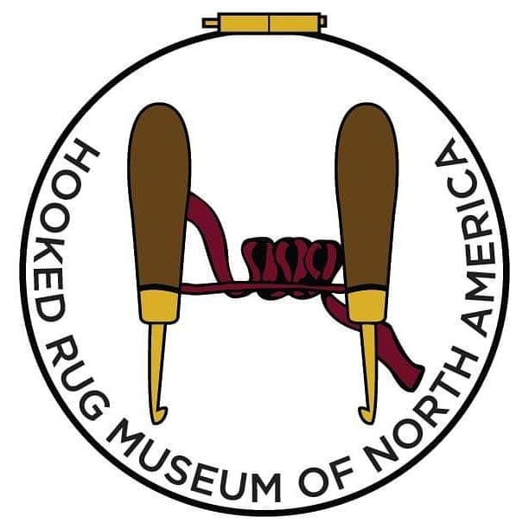

Job Opportunity: Retail Sales Associate

Location: The Hooked Rug Museum of North America
9849 St. Margarets Bay Rd. - border of Queensland and Hubbards

Job Summary
The Hooked Rug Museum of North America is committed to the preservation and curation of the history of rug hooking and the impact it has on Nova Scotia and the wider community. Each year the museum welcomes visitors from all over the world who come to soak in the artistry of the works we display, learn something new in the workshops or pick up supplies for their next project.

As Retail Sales Associate in the Fibre Art Market, you will play an integral role on the team, engaging and connecting to museum visitors by providing excellent customer service. You will be an important part of creating a welcoming environment that promotes community and crafting. A willingness to learn about the craft of rug hooking is very important.

Responsibilities
- Acknowledge and manage customer interactions with care
- Provide customer-focused, friendly service to visitors in the museum and Fibre Art Market
- Assist with preparing rug hooking supplies, kits, and packaging
- Perform daily sales procedures - assisting customers, processing sales, and balancing sales receipts at the end of the day
- Light housekeeping to maintain the cleanliness of the museum and Fibre Art Market
- Assist with other small tasks as they pertain to ongoing events and projects

Qualifications
- Excellent verbal communication skills
- Strong attention to detail and organizational skills
- Demonstrated proficiency in cash handling procedures and the ability to reconcile a cash draw at the end of the business day
- Strong interpersonal skills and a service mindset

Eligibility
The Hooked Rug Museum of North America has been approved through the Canada Summer jobs program. The museum is seeking a person between the ages of 18-30 (inclusive) at the start of employment. Students are welcome to apply but do not need to be returning to school.

Applicants must be legally entitled to work in Canada (Canadian citizen, permanent resident, or person with refugee protection under the Immigration or Refugee Protection Act).

How to Apply
Please submit your resume or for more information, email hookedrugmuseum@gmail.com.

Job Type: Seasonal
Contract length: 9 weeks
Pay: $16.75 per hour

