JACOBEAN WORKSHOP
Hooked Rug Museum of North America (HRMNA)
Pattern for class 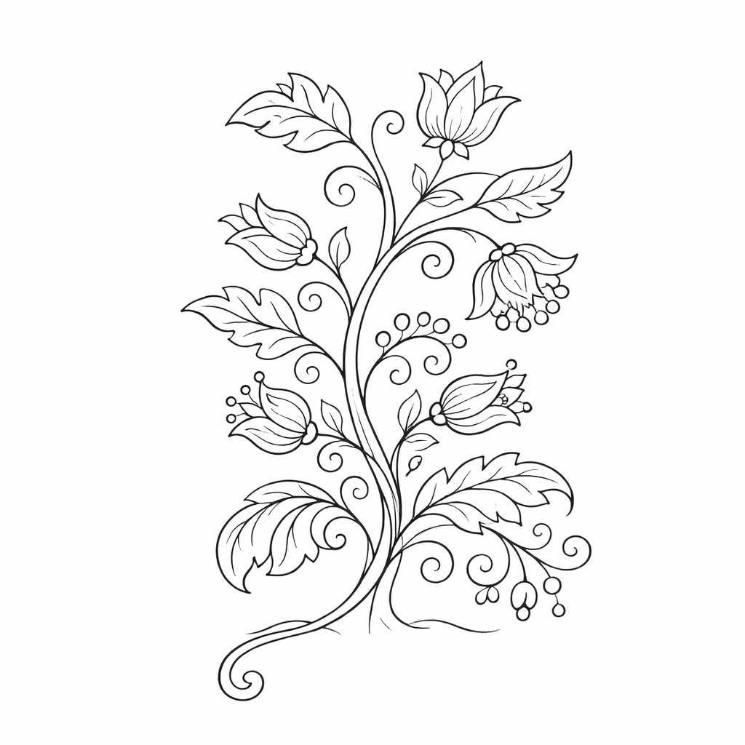 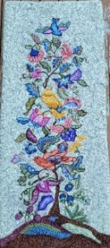 Sample only

DATE: August 18 & 19 (2 days) Tuesday & Wednesday 9:30am - 4:00pm

LOCATION: Hooked Rug Museum of North America (HRMNA)
9849 St. Margaret’s Bay Road, Queensland, NS B0J 1T0 902-858-3060
Web: http://www.hookedrugmuseumnovascotia.org email: hookedrugmuseum@gmail.com

TEACHER: Patsy Gorveatte, Certified Rug Hooking Teacher

WORKSHOP: In this 2-day class, we will be learning what makes up a Jacobean Pattern. We look at colour palettes, design motifs, various stitches, and so much more. Jacobean style hooking is just that. It’s a design filled with crewel stitches and shapes.

Jacobean is from the 1600’s King James I era also known as the Jacobean Era. William Morris’ artwork had a massive impact and transitions beautifully into Jacobean rug hooking. We will be working on a 20” x 20” pattern, perfect for a framed piece, a trivet, or throw cushion. You will be asked to bring 6 – 3 value swatches or you can use 6 or 8 value swatches by using every second value. Please don’t select bold, garish colours that will not serve the Jacobean era. These are more rich, jewel tones. You can use faded out versions of these colours as well. You will need a neutral background colour that goes with your palette. It can be a very, very, light version of any of your values or it could be a spot dye with very neutral colour.

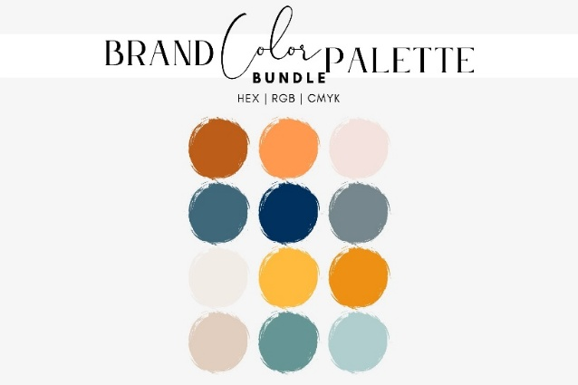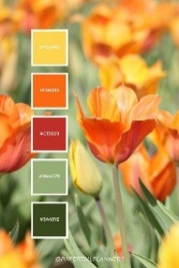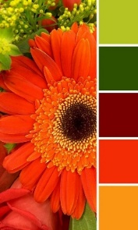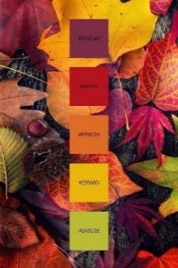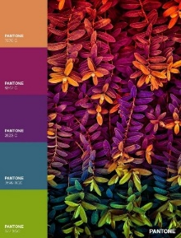

PATTERN: The pattern on linen costs $65.00

COST: Total cost – $165.00 which includes - registration for 2 days plus cost of pattern.

A Deposit of $65.00 is required to register.

REGISTRATION: Print and Fill in the Registration Form. It cannot be completed online.
Scan and email it to: hookedrugmuseum@gmail.com OR mail it to the Registrar at the address below.

- E-TRANSFER your deposit or payment in full to: hookedrugmuseum@gmail.com
OR
- CHEQUE – Mail cheque and registration form to the address below.
OR
- MUSEUM – Stop into the Museum, fill out a registration form and make payment at the front counter.

REGISTRAR: HOOKED RUG MUSEUM of NORTH AMERICA
9849 St. Margaret’s Bay Road, Queensland, NS B0J 1T0

Confirmation of registration upon receipt of both registration form and payment.

- Coffee,tea will be provided. Please bring your own lunch, snacks, cutlery and mug.
- Please do not bring anything with nuts due to severe allergy concerns.

CANCELLATION/REFUNDS: Deposit of $65.00 is refundable prior to August 1, 2026. No refunds after August 1, 2026.

** Any questions, please call Sherry Chandler @ 902-275-4743 or email hookedrugmuseum@gmail.com

