MONOCHROMATIC WORKSHOP
Hooked Rug Museum of North America (HRMNA)

Monochromatic plus a Pop of Colour

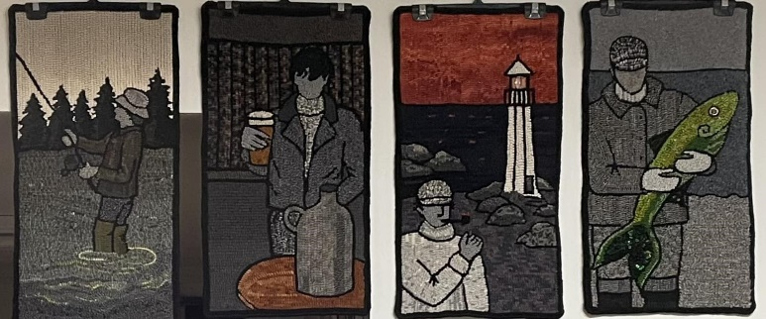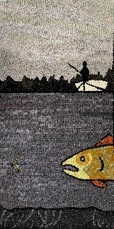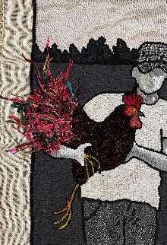
SAMPLES

DATE: September 2nd & 3rd, 2026 Wednesday & Thursday 9:30am - 4:00pm

LOCATION: Hooked Rug Museum of North America (HRMNA)
9849 St. Margaret’s Bay Road, Queensland, NS B0J 1T0 902-858-3060
Web: http://www.hookedrugmuseumnovascotia.org email: hookedrugmuseum@gmail.com

TEACHER: JANE STEELE is the owner of River House Rug Hooking Studio, Petite Riviere Bridge , NS. Jane studied textile marketing in England and worked with many European Mills supplying the UK garment industry. Moving to Nova Scotia in 2010, Jane started to plan a way to put her knowledge and love of colour, fabric and design into a business. She learned how to hook and quickly became “hooked”.

WORKSHOP: Jane can offer many designs and 2 sizes – 13 x 25 inches and 13 x 13 inches. She also has about 20 other designs and students can look on the River House Rug Hooking FB page to view them.
Jane will bring supplies. Lots of interesting options – dip dyed skies, funky fibres, embellishments.
Students can bring their own supplies plus give thought to their colour pop, which can be anything!
This series is a lot of fun and gets addictive.

SUPPLY COST: The pattern on linen costs $70 for 13” x 25” and $45.00 for 13” x 13”
Contact Jane to purchase either at: 902-693-3111 or jane.riverhouse@gmail.com

REGISTRATION FEE: - $100.00 - (not including pattern or supplies) A Deposit of $50.00 is required to register.

REGISTRATION: Print and Fill in the Registration Form. It cannot be completed online.
Scan and email it to: hrmnaevents@gmail.com

- E-TRANSFER your deposit or payment in full to: hrmnaevents@gmail.com
OR
- CHEQUE – Mail cheque and registration form to the address below.
OR
- MUSEUM – Stop into the Museum, fill out a registration form and make payment at the front counter.

REGISTRAR: HOOKED RUG MUSEUM of NORTH AMERICA
9849 St. Margaret’s Bay Road, Queensland, NS B0J 1T0

Confirmation of registration upon receipt of both registration form and payment.

- Coffee,tea will be provided. Please bring your own lunch, snacks, cutlery and mug.
- Please do not bring anything with nuts due to severe allergy concerns.

CANCELLATION/REFUNDS: Deposit of $50.00 is refundable prior to August 15, 2026. No refunds after August 15, 2026.

** Any questions, please call Sherry Chandler @ 902-275-4743 or email hookedrugmuseum@gmail.com

