PAISLEY FISH
Hooked Rug Museum of North America (HRMNA)

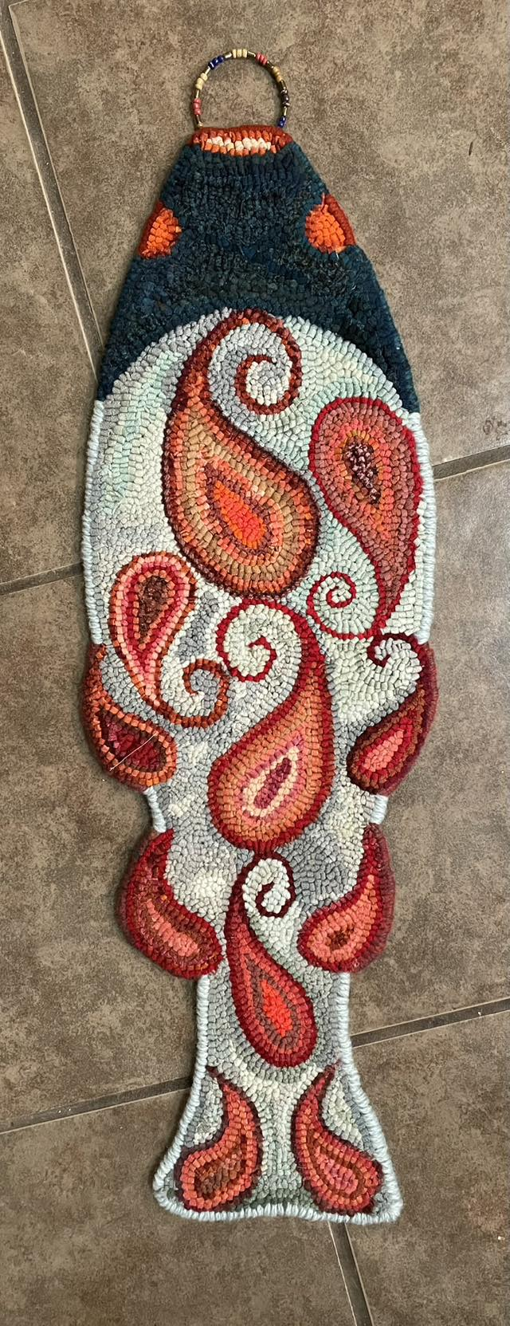

DATE: JUNE 16 & 17 (2 days) Tuesday & Wednesday 9:30am - 4:00pm

LOCATION: Hooked Rug Museum of North America (HRMNA)
9849 St. Margaret’s Bay Road, Queensland, NS B0J 1T0 902-858-3060
Web: http://www.hookedrugmuseumnovascotia.org email: hookedrugmuseum@gmail.com

TEACHER: JANE STEELE is the owner of River House Rug Hooking Studio, Petite Riviere Bridge , NS. Jane studied textile marketing in England and worked with many European Mills supplying the UK garment industry. Moving to Nova Scotia in 2010, Jane started to plan a way to put her knowledge and love of colour, fabric and design into a business. She learned how to hook and quickly became “hooked”.

WORKSHOP: This is a new pattern of a fish, 30 inches long, with paisleys in the body and for the fins. It’s been very popular and people are waiting to sign up for this class. Colours will be the students own choose and mixed cuts, silks, yarns can be used.
Bring along any embellishments you plan to use, for example – broken jewellery, beads, braid, etc.

PATTERN: The pattern on linen costs $60.00

COST: Total cost – $160.00 (includes - 2 days $100.00 plus cost of pattern $60.00 for a total of $160.00
A Deposit of $80.00 is required to register.

REGISTRATION: Print and Fill in the Registration Form. It cannot be completed online.
Scan and email it to: hookedrugmuseum@gmail.com OR mail it to the Registrar at the address below.

- E-TRANSFER your deposit or payment in full to: hookedrugmuseum@gmail.com
OR
- CHEQUE – Mail cheque and registration form to the address below.
OR
- MUSEUM – Stop into the Museum, fill out a registration form and make payment at the front counter.

REGISTRAR: HOOKED RUG MUSEUM of NORTH AMERICA
9849 St. Margaret’s Bay Road, Queensland, NS B0J 1T0

Confirmation of registration upon receipt of both registration form and payment.

- Coffee,tea will be provided. Please bring your own lunch, snacks, cutlery and mug.
- Please do not bring anything with nuts due to severe allergy concerns.

CANCELLATION/REFUNDS: Deposit of $80.00 is refundable prior to June 1, 2026. No refunds after June 1, 2026.

** Any questions, please call Sherry Chandler @ 902-275-4743 or email hookedrugmuseum@gmail.com

