2 SIDED PUNCHING (2 days)
Hooked Rug Museum of North America
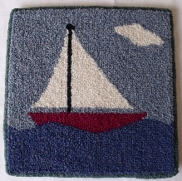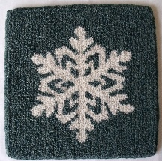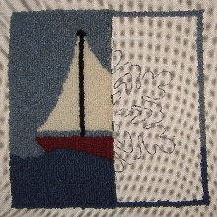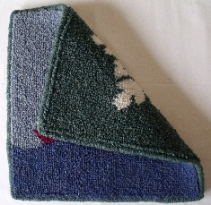
SAMPLE ONLY OF A 2 SIDED PUNCHED RUG

DATE: June 28, 2026 Sunday 9:30am - 4:00pm
June 29, 2026 Monday 9:30am – 4:00pm

LOCATION: Hooked Rug Museum of North America (HRMNA)
9849 St. Margaret’s Bay Road, Hwy 3, Queensland, NS B0J 1T0 902-858-3060
Web: http://www.hookedrugmuseumnovascotia.org email: hookedrugmuseum@gmail.com

TEACHER: Kevin LeMoine , Advanced Oxford Certified Instructor lives in Shemogue, New Brunswick. After many forays in the Fiber Arts, including Punch Needle Embroidery, Cross Stitch, Needlepoint and Latch Hook, Kevin was introduced to Traditional Rug Hooking by his Mother. Kevin has evolved into Punch Needle Rug Hooking where he has found great peace and relaxation in using the Amy Oxford Punch Needle. Kevin is offering classes throughout the area and has opened his own studio, visit him at: www.punchneedlerughooking.ca
WORKSHOP: Limited to 12 persons. This method of Rug Punching is for the individual that wants to challenge themselves and must be prepared to concentrate and focus on their piece as it is developing in front of their eyes. We will discuss the origin of the 2 – sided punching process along with jumping right into our pieces. Finished piece will measure 12” x 12” punched on a single piece of Monk’s Cloth backing. Oxford Punch needles and Gripper Frames will be available to use during the class with the option to purchase.

All students signed up before June 7, 2026 will be contacted by Kevin to choose their 2 projects. (1 for each side) from a selection available, making each project in the course different. Anyone signing up after June 7th, 2026 will have patterns chosen by Kevin.

COST: Total registration fee is $ 185.00. Includes “KIT” and registration fee for 2 days.
A Deposit of $85.00 is required to register.

REGISTRATION: Click here to Download, Print and Fill in the Registration Form. It cannot be completed online.
Scan and email it to: hookedrugmuseum@gmail.com OR mail it to the Registrar at the address below.

- E-TRANSFER your deposit or payment in full to: hookedrugmuseum@gmail.com
OR
- CHEQUE – Mail cheque and registration form to the address below.
OR
- MUSEUM – Stop into the Museum, fill out a registration form and make payment at the front counter.

REGISTRAR: HOOKED RUG MUSEUM of NORTH AMERICA
9849 St. Margaret’s Bay Road, Queensland, NS B0J 1T0

Confirmation of registration upon receipt of both registration form and payment.

- Coffee,tea will be provided. Please bring your own lunch, snacks, cutlery and mug. - Please do not bring anything with nuts due to severe allergy concerns.

CANCELLATION/REFUNDS: Deposit of $85.00 is refundable prior to June 1, 2026. No refunds after June 1, 2026.

** Any questions, please call Sherry Chandler @ 902-275-4743 or email hookedrugmuseum@gmail.com

