BEGINNER PUNCH HOOKING
Hooked Rug Museum of North America

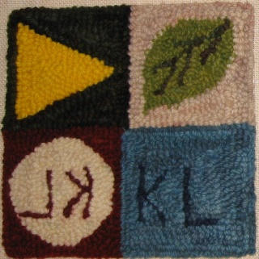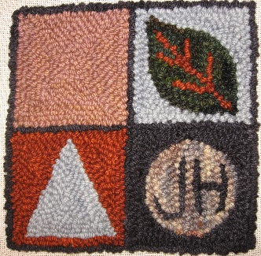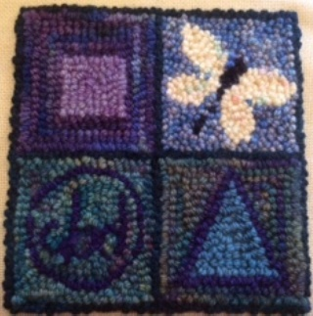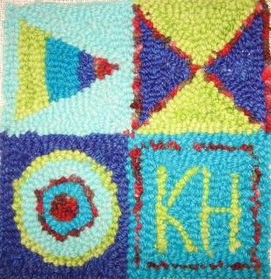

DATE: August 28, 2026 Saturday 9:30am - 4:00pm

LOCATION: Hooked Rug Museum of North America (HRMNA)
9849 St. Margaret’s Bay Road, Hwy 3, Queensland, NS B0J 1T0 902-858-3060
Web: http://www.hookedrugmuseumnovascotia.org email: hookedrugmuseum@gmail.com

TEACHER: Kevin LeMoine , Advanced Oxford Certified Instructor lives in Shemogue, New Brunswick. After many forays in the Fiber Arts, including Punch Needle Embroidery, Cross Stitch, Needlepoint and Latch Hook, Kevin was introduced to Traditional Rug Hooking by his Mother. Kevin has evolved into Punch Needle Rug Hooking where he has found great peace and relaxation in using the Amy Oxford Punch Needle. Kevin is offering classes throughout the area and has opened his own studio, visit him at: www.punchneedlerughooking.ca

WORKSHOP: Limited to 12 persons. If you always admired hooked rugs and would like to try your hand at making one, then this is your chance. This course is designed to have you complete a small “Beginner Sampler Kit” designed by Judith Hotchkiss & Kevin LeMoine using a #10 Regular Oxford Punch Needle. This kit is designed to teach the technique and fundamentals of Punch Needle Rug Hooking while allowing each student to customize their mat with a choice of templates. Your kit will include the pattern on a 24” x 24” piece of monk’s cloth and a selection of 4 ply yarns to complete the project. Punch Needles and Frames will be available to use during class or to purchase after the class.
“This is a fast and rewarding craft that I look forward to introducing into your life!”

COST: Total cost is $ 85.00. Includes pattern on Monk’s Cloth, ALL yarn and registration fee.

A Deposit of $45.00 is required to register.

REGISTRATION: Click here to Download, Print and Fill in the Registration Form. It cannot be completed online.
Scan and email it to: hrmnaevents@gmail.com OR mail it to the Registrar at the address below.

- E-TRANSFER your deposit or payment in full to: hrmnaevents@gmail.com
OR
- CHEQUE – Mail cheque and registration form to the address below.
OR
- MUSEUM – Stop into the Museum, fill out a registration form and make payment at the front counter.

REGISTRAR: HOOKED RUG MUSEUM of NORTH AMERICA
9849 St. Margaret’s Bay Road, Queensland, NS B0J 1T0

Confirmation of registration upon receipt of both registration form and payment.
- Coffee,tea will be provided. Please bring your own lunch, snacks, cutlery and mug. Please do not bring anything with nuts due to severe airborne allergy concerns.
CANCELLATION/REFUNDS:
Deposit of $45.00 is refundable prior to August 1, 2026. No refunds after August 1, 2026.

** Any questions, please call Sherry Chandler @ 902-275-4743 or email hookedrugmuseum@gmail.com

