PUNCHING WITH WOOL STRIPS
Hooked Rug Museum of North America

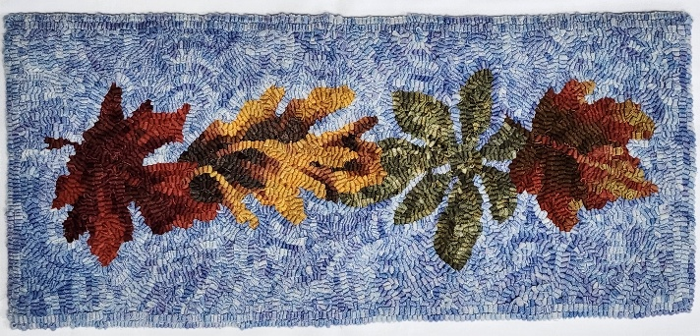

DATE: August 29, 2026 Saturday 9:30am - 4:00pm

LOCATION: Hooked Rug Museum of North America (HRMNA)
9849 St. Margaret’s Bay Road, Hwy 3, Queensland, NS B0J 1T0 902-858-3060
Web: http://www.hookedrugmuseumnovascotia.org email: hookedrugmuseum@gmail.com

TEACHER: Kevin LeMoine , Advanced Oxford Certified Instructor lives in Shemogue, New Brunswick. After many forays in the Fiber Arts, including Punch Needle Embroidery, Cross Stitch, Needlepoint and Latch Hook, Kevin was introduced to Traditional Rug Hooking by his Mother. Kevin has evolved into Punch Needle Rug Hooking where he has found great peace and relaxation in using the Amy Oxford Punch Needle. Kevin is offering classes throughout the area and has opened his own studio, visit him at: www.punchneedlerughooking.ca

WORKSHOP: Limited to 12 persons.
We will be Punch Needle Rug Hooking with wool strips that will be pre-cut in a #6 cut and using a #10 Regular Oxford Punch Needle. All wools will be Hand Dyed/Over Dyed and provided in your kit. The finished piece is 9.5” x 21”. Kevin will be providing, for use during the workshop or you can purchase from him, a Gripper Frame and Oxford Punch Needles for all students.

COST: Total cost is $ 120.00. Includes Kit (pattern & wool) and registration fee.

A Deposit of $60.00 is required to register.

REGISTRATION: Click here to Download, Print and Fill in the Registration Form. It cannot be completed online.
Scan and email it to: hrmnaevents@gmail.com OR mail it to the Registrar at the address below.

- E-TRANSFER your deposit or payment in full to: hrmnaevents@gmail.com
OR
- CHEQUE – Mail cheque and registration form to the address below.
OR
- MUSEUM – Stop into the Museum, fill out a registration form and make payment at the front counter.

REGISTRAR: HOOKED RUG MUSEUM of NORTH AMERICA
9849 St. Margaret’s Bay Road, Queensland, NS B0J 1T0

Confirmation of registration upon receipt of both registration form and payment.
- Coffee,tea will be provided. Please bring your own lunch, snacks, cutlery and mug. Please do not bring anything with nuts due to severe airborne allergy concerns.

CANCELLATION/REFUNDS:
Deposit of $60.00 is refundable prior to August 1, 2026. No refunds after August 1, 2026.

** Any questions, please call Sherry Chandler @ 902-275-4743 or email hookedrugmuseum@gmail.com

