SHADY LADIES
Hooked Rug Museum of North America (HRMNA)

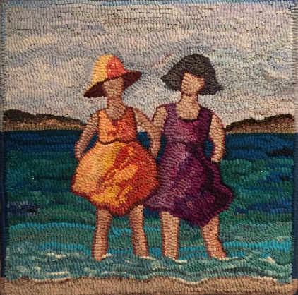

DATE: JULY 15, 2026 Wednesday 9:30am - 4:00pm

LOCATION: Hooked Rug Museum of North America (HRMNA)
9849 St. Margaret’s Bay Road, Queensland, NS B0J 1T0 902-858-3060
Web: http://www.hookedrugmuseumnovascotia.org email: hookedrugmuseum@gmail.com

TEACHER: JANE STEELE is the owner of River House Rug Hooking Studio, Petite Riviere Bridge , NS. Jane studied textile marketing in England and worked with many European Mills supplying the UK garment industry. Moving to Nova Scotia in 2010, Jane started to plan a way to put her knowledge and love of colour, fabric and design into a business. She learned how to hook and quickly became “hooked”.

WORKSHOP: This is a 16” square, 2 (or 3) ladies with their feet in the water, wearing sunhats, and poofy dresses in which there is primitive shading. (Or fine shading………) Nice bold colours, happy!! Could be 2 friends, sisters……………

PATTERN: The pattern on linen costs $50.00

COST: Total cost – $100.00 which includes - registration plus cost of pattern.

A Deposit of $50.00 is required to register.

REGISTRATION: Print and Fill in the Registration Form. It cannot be completed online.
Scan and email it to: hookedrugmuseum@gmail.com OR mail it to the Registrar at the address below.

- E-TRANSFER your deposit or payment in full to: hookedrugmuseum@gmail.com
OR
- CHEQUE – Mail cheque and registration form to the address below.
OR
- MUSEUM – Stop into the Museum, fill out a registration form and make payment at the front counter.

REGISTRAR: HOOKED RUG MUSEUM of NORTH AMERICA
9849 St. Margaret’s Bay Road, Queensland, NS B0J 1T0

Confirmation of registration upon receipt of both registration form and payment.

- Coffee,tea will be provided. Please bring your own lunch, snacks, cutlery and mug.
- Please do not bring anything with nuts due to severe allergy concerns.

CANCELLATION/REFUNDS: Deposit of $50.00 is refundable prior to July 1, 2026. No refunds after July 1, 2026.

** Any questions, please call Sherry Chandler @ 902-275-4743 or email hookedrugmuseum@gmail.com

